Contact: Laura Frnka-Davis
Storyteller Communications
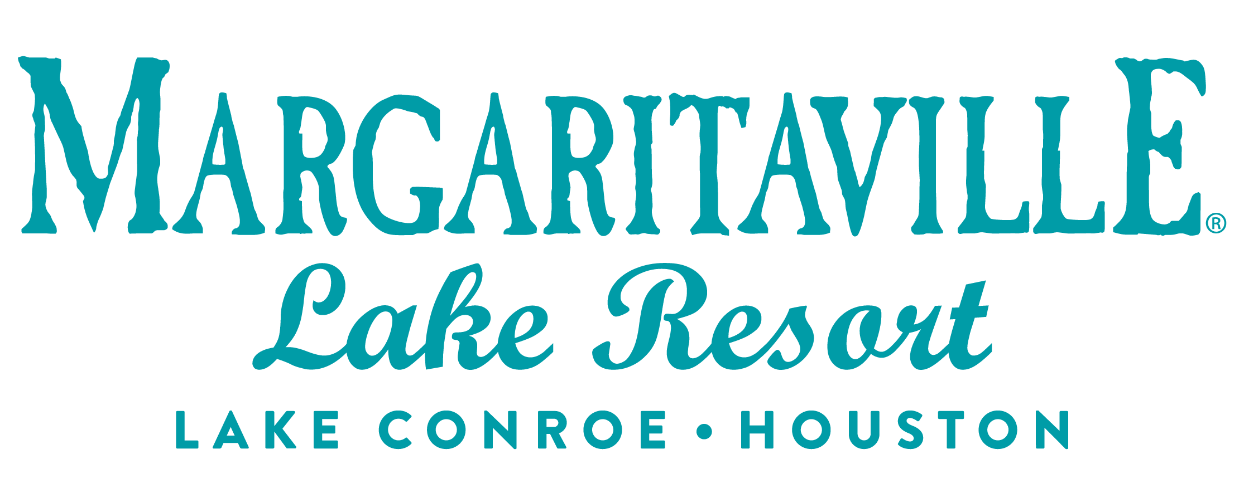
713-409-1480 phone
laura@storytellercomm.com

MEDIA ALERT
Save Lives. Give Blood.
Margaritaville Lake Resort, 5 o’Clock Phlock, and Rotary Club of Lake Conroe Set to Host Holiday Blood Drive

WHAT: Margaritaville Lake Resort Lake Conroe | Houston, along with the 5 o’Clock Phlock Parrot Head Club of Montgomery County and the Rotary Club of Lake Conroe will host a “Pints for A Purpose” blood drive benefiting the Gulf Coast Regional Blood Center.

Donors will receive a specially designed 5 o’Clock Phlock Parrot Head Club t-shirt and stocking stuffers. To celebrate blood donors, LandShark Bar & Grill will open at 9:00 a.m. and will be serving up the Parrot Burger – a fresh hamburger patty topped with American cheese, lettuce, tomato, onion, and pickles, along with Margaritaville’s famous LandShark sauce for $9.

WHEN: Saturday, Dec. 2nd
9 a.m. to 3 p.m.

WHERE: LandShark Bar & Grill
Margaritaville Lake Resort Lake Conroe | Houston
600 Margaritaville Parkway
Montgomery, Texas 77356

WHY: Throughout the holiday season, blood donations tend to dip when the need is at its greatest due to accidents and widespread illness.

Parrot Head Clubs throughout the country are hosting blood drives on Dec. 2^{nd.}

To sign up to give the gift of life, visit www.giveblood.org.

MORE: About Margaritaville Lake Resort Lake Conroe | Houston
The Margaritaville Lake Resort Lake Conroe | Houston, an all-suite resort, features 335 guest suites; including 32 lakefront cottages, on 186 lakefront acres on Lake Conroe. It is the first Margaritaville Resort in Texas. Bars and restaurants feature signature Margaritaville dining concepts – the LandShark Bar & Grill with boat slips on Lake Conroe, the 5 o’Clock Somewhere Bar, the Lone Palm Pool Bar, the License to Chill Bar & Café, Joe Merchant’s Coffee & Provisions, Boathouse Bar and Lounge, and a Margaritaville Retail Shop.

Margaritaville Lake Resort Lake Conroe | Houston offers an array of recreational activities: an 18-hole golf course, a three-acre waterpark with a lazy river and outdoor pools, pickleball, tennis, swimming, boating, and fishing. Margaritaville’s popular full-service St. Somewhere Spa, and a spacious, Fins Up Fitness Center, provide exceptional wellness options. With 72,000 square feet of indoor/outdoor IACC-approved meeting space, the resort can host special events and meetings of every size. Located just an hour from Houston and about three hours from the major hubs of Austin, Dallas and San Antonio, the resort is within easy reach of over 19 million Texans. The project is a joint venture of Songy Highroads (SHR) and The Wampold Companies. The Margaritaville Lake Resort Lake Conroe |Houston, is part of BENCHMARK®, a global hospitality company’s Benchmark Resorts & Hotels portfolio.

About Benchmark Pyramid
Benchmark Pyramid was formed by the 2021 merger of two hotel and resort management companies, creating the most owner-focused, experiential company in the industry and its best workplace. The organization’s global portfolio spans more than 240 properties in the U.S., Caribbean and Europe. It maintains offices in Boston; The Woodlands, Texas; Cincinnati; and London. For more information, visit www.benchmarkpyramid.com.

# # #

