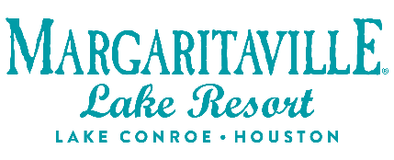
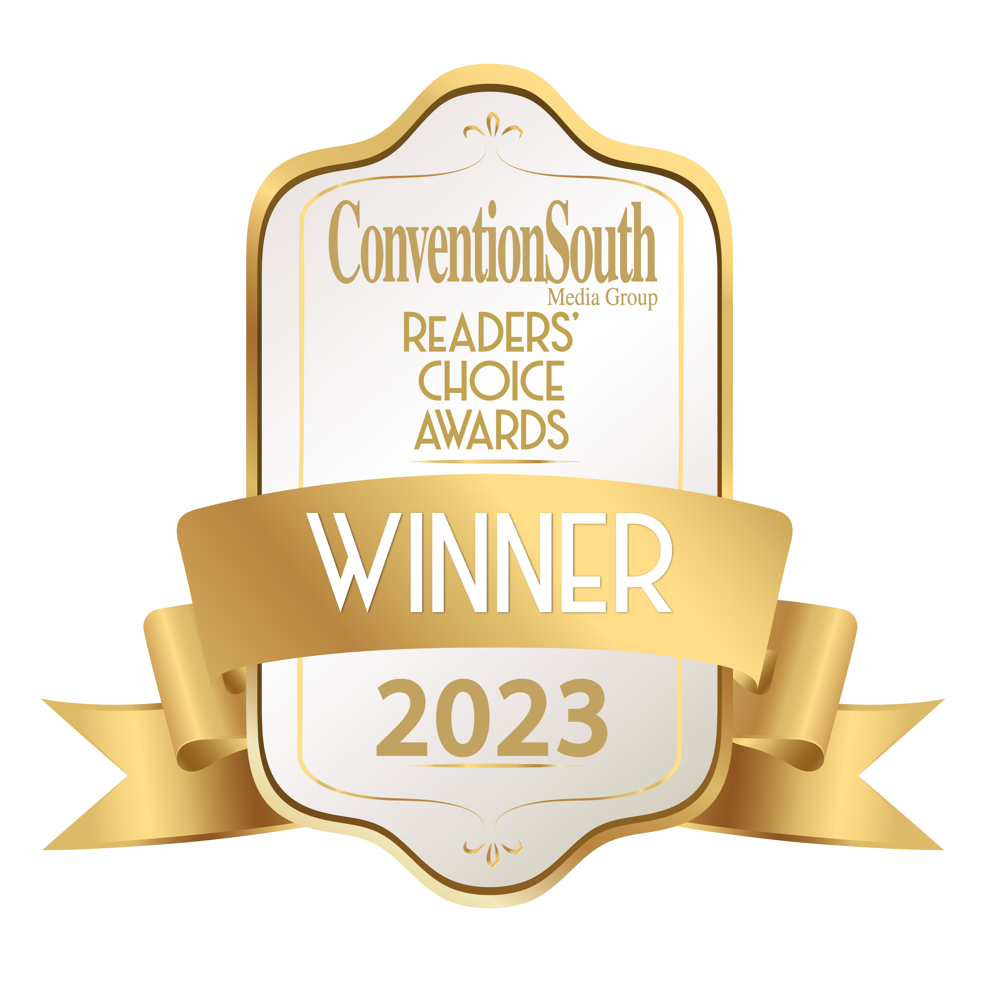

FOR IMMEDIATE RELEASE Media Contact:
Laura Frnka-Davis
Storyteller Communications
713-409-1480
laura@storytellercomm.com

Margaritaville Lake Resort Lake Conroe Once Again Honored with ConventionSouth’s
Annual Reader’s Choice Award

Montgomery, TX (Nov. 7, 2023) - Margaritaville Lake Resort Lake Conroe | Houston announced today that it is a recipient of a ConventionSouth Annual Reader’s Choice Award for the third consecutive year. The resort was one of only 64 winners across the entire state of Texas, including convention and visitor bureaus and other meeting venues.

“Margaritaville Lake Resort Lake Conroe | Houston is proud of this ConventionSouth distinction and our ability to create one-of-a-kind experiences for meeting and event attendees across all industries,” said Tom Faust, vice president of sales and marketing for Margaritaville Lake Resort Lake Conroe | Houston. “We look forward to hosting groups at our tropical-inspired resort, conveniently located an hour north of the Greater Houston area.”

The resort provides an array of purpose-built meeting spaces, many with natural light to augment learning and engagement. In addition, it offers 13 different on-brand team-building exercises, including “The Continental Drifter,” “Cardboard Boat Regatta,” and “Nama-Stay in Paradise” lakefront yoga classes. After the hard work is done, they can enjoy six island-inspired restaurants, an 18-hole golf course, an 18,000-square-foot wellness retreat, St. Somewhere Spa, and a state-of-the-art workout facility, Fins Up Fitness Center.

Margaritaville Lake Resort is among 446 convention and visitor bureaus, meeting facilities, and hotels across the South to receive this year’s Reader’s Choice Award. Throughout the year, meeting professionals nominated the meeting sites they believe provide exemplary service for group events. The selected sites are then compiled onto an online ballot where meeting professionals and fans are asked to vote for the best of the best.

“ConventionSouth readers and fans have once again voted to decide the best meeting sites in the South, and it is no surprise to us that Margaritaville Lake Resort Lake Conroe has been selected to receive our annual Readers’ Choice Award,” said ConventionSouth Associate Publisher Tiffany Burtnett. “This prestigious recognition comes from the United States’ top meeting professionals who hold events in the South. These planners demand the highest level of customer service and quality facilities, and they have determined that Margaritaville Lake Resort Lake Conroe indeed displays the commitment to professionalism, creativity, and service that they require.”

For this designation, Margaritaville Lake Resort will be highlighted in the December 2023 awards issue of ConventionSouth.

A leading meeting planning resource for Southern destinations, ConventionSouth Magazine is distributed to more than 18,000 meeting professionals across the country who hold events in the South.

For more information about Margaritaville Lake Resort, visit https://www.margaritavilleresorts.com/margaritaville-lake-resort-lake-conroe.

# # #

About Margaritaville Lake Resort Lake Conroe | Houston
The Margaritaville Lake Resort Lake Conroe | Houston, an all-suite resort, features 335 guest suites; including 32 lakefront cottages, on 186 lakefront acres on Lake Conroe. It is the first Margaritaville Resort in Texas. Bars and restaurants feature signature Margaritaville dining concepts – the LandShark Bar & Grill with boat slips on Lake Conroe, the 5 o’Clock Somewhere Bar, the Lone Palm Pool Bar, the License to Chill Bar & Café, Joe Merchant’s Coffee & Provisions, Boathouse Bar and Lounge, and a Margaritaville Retail Shop.
Margaritaville Lake Resort Lake Conroe | Houston offers an array of recreational activities: an 18-hole golf course, a three-acre waterpark with a lazy river and outdoor pools, pickleball, tennis, swimming, boating, and fishing. Margaritaville’s popular full-service St. Somewhere Spa, and a spacious, Fins Up Fitness Center, provide exceptional wellness options. With 72,000 square feet of indoor/outdoor IACC-approved meeting space, the resort can host special events and meetings of every size. Located just an hour from Houston and about three hours from the major hubs of Austin, Dallas and San Antonio, the resort is within easy reach of over 19 million Texans. The project is a joint venture of Songy Highroads (SHR) and The Wampold Companies. The Margaritaville Lake Resort, Lake Conroe |Houston, is part of BENCHMARK®, a global hospitality company’s Benchmark Resorts & Hotels portfolio.

Margaritaville features over 40 hotels and resorts, gaming properties, RV destinations, a cruise line, and over 150 food and beverage venues – as well as real estate communities, a satellite radio station on SiriusXM, consumer lifestyle products, and more. In 2023, Margaritaville Hotels & Resorts was ranked #1 in Guest Satisfaction among Upper Upscale Hotel Brands in the J.D. Power 2023 North America Hotel Guest Satisfaction Study.

About Benchmark Pyramid
Benchmark Pyramid was formed by the 2021 merger of two hotel and resort management companies, creating the most owner-focused, experiential company in the industry and its best workplace. The organization’s global portfolio spans more than 240 properties in the U.S., Caribbean and Europe. It maintains offices in Boston; The Woodlands, Texas; Cincinnati; and London. For more information, visit www.benchmarkpyramid.com.

