Contact: Laura Frnka-Davis
Storyteller Communications
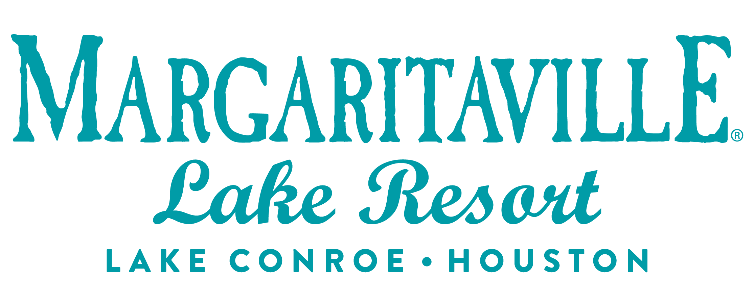
713-409-1480 phone
laura@storytellercomm.com

MEDIA ALERT
Enjoy “Breakfast with Santa” at Margaritaville Lake Resort

WHAT: Choo! Choo! All aboard for Breakfast with Santa at Margaritaville Lake Resort Lake Conroe | Houston! Jolly Ole’ St. Nick will be arriving via the Magical Margaritaville Express to have breakfast in paradise. Enjoy a magical and enchanting morning as you create lasting fun family memories!

Indulge in a variety of scrumptious holiday favorites as you soak in the sights and sounds of the holiday season. Share the joy and bring a new and unwrapped board game for the Community Assistance Center of Montgomery County.

For more information and to view the menu, visit here. Reservations are highly recommended by calling 877.286.9590.

    - Adults: $39.95 ++
    - Children (6 to 12): $24.95 ++
    - Children 5 and under eat free
    - Members receive 20% off

WHEN: Saturday, Dec. 16 from 8:30 a.m. to 12:30 p.m.
Sunday, Dec. 17 from 10 a.m. to 2 p.m.

WHERE: Margaritaville Lake Resort
Del Lago Ballroom
600 Margaritaville Parkway
Montgomery, Texas 77356

WHAT ELSE: Breakfast with Santa guests can hop aboard the Magical Margaritaville Express and take a trip around the resort from 9 a.m. to 5 p.m. on Saturday, Dec. 16 and 10:30 a.m. to 5 p.m. on Sunday, Dec. 17. Rides are $10 per person and will begin and end near the resort lobby at Einstein’s Surf and Boat Shop.

Make it a weekend to remember by taking advantage of the resort’s “Paradise for the Holidays” package for just $149 a night. As the resort’s special gift to you, they will discount the resort fee to $25 nightly for your entire stay. For more details and to learn more, visit the website.

MORE: About Margaritaville Lake Resort Lake Conroe | Houston
The Margaritaville Lake Resort Lake Conroe | Houston, an all-suite resort, features 335 guest suites; including 32 lakefront cottages, on 186 lakefront acres on Lake Conroe. It is the first Margaritaville Resort in Texas. Bars and restaurants feature signature Margaritaville dining concepts – the LandShark Bar & Grill with boat slips on Lake Conroe, the 5 o’Clock Somewhere Bar, the Lone Palm Pool Bar, the License to Chill Bar & Café, Joe Merchant’s Coffee & Provisions, Boathouse Bar and Lounge, and a Margaritaville Retail Shop.

Margaritaville Lake Resort Lake Conroe | Houston offers an array of recreational activities: an 18-hole golf course, a three-acre waterpark with a lazy river and outdoor pools, pickleball, tennis, swimming, boating, and fishing. Margaritaville’s popular full-service St. Somewhere Spa, and a spacious, Fins Up Fitness Center, provide exceptional wellness options. With 72,000 square feet of indoor/outdoor IACC-approved meeting space, the resort can host special events and meetings of every size. Located just an hour from Houston and about three hours from the major hubs of Austin, Dallas and San Antonio, the resort is within easy reach of over 19 million Texans. The project is a joint venture of Songy Highroads (SHR) and The Wampold Companies. The Margaritaville Lake Resort Lake Conroe |Houston, is part of BENCHMARK®, a global hospitality company’s Benchmark Resorts & Hotels portfolio.

About Pyramid Global Hospitality
Pyramid Global Hospitality was formed by the 2021 merger of two hotel and resort management companies, creating the most owner-focused, experiential company in the industry and its best workplace. The organization’s global portfolio spans more than 240 properties in the U.S., Caribbean and Europe. It maintains offices in Boston; The Woodlands, Texas; Cincinnati; and London. For more information, visit www.benchmarkpyramid.com.

# # #

