Contact: Laura Frnka-Davis
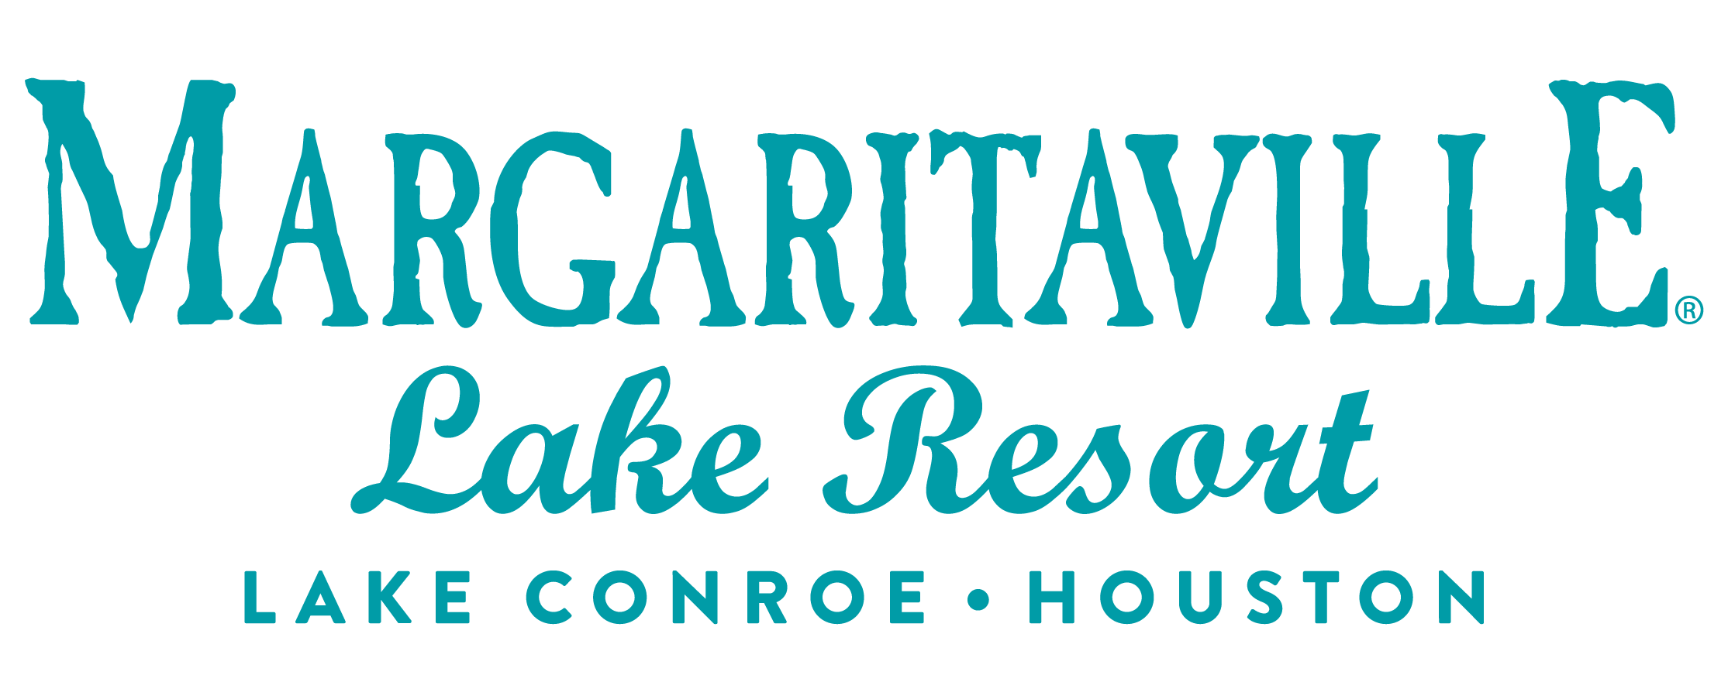
Storyteller Communications
713-409-1480 phone
laura@storytellercomm.com

MEDIA ALERT
Catch Game Day Specials at Margaritaville Lake Resort, Lake Conroe | Houston

WHAT: Score big with your friends at Margaritaville Lake Resort, Lake Conroe | Houston with $5 draft beer, $14 tasty wings, and lakeside vibes as the Philadelphia Eagles take on the Kansas City Chiefs. Choose from buffalo, buffalo sriracha, teriyaki, garlic parmesan, Jamaican jerk, or honey BBQ wings you settle in for an afternoon of football fun at LandShark Bar & Grill.

WHEN: Sunday, Feb. 12, 2023
Specials served all day at LandShark Bar & Grill

WHERE: LandShark Bar & Grill
Margaritaville Lake Resort, Lake Conroe | Houston
600 Margaritaville Parkway, Montgomery, TX 77356

WHAT ELSE: About Margaritaville Lake Resort, Lake Conroe | Houston
The Margaritaville Lake Resort, Lake Conroe | Houston, an all-suite resort, features 335 guest suites; including 32 lakefront cottages, on 186 lakefront acres on Lake Conroe. It is the first Margaritaville Resort in Texas. Bars and restaurants feature signature Margaritaville dining concepts – the LandShark Bar & Grill with boat slips on Lake Conroe, the 5 o’Clock Somewhere Bar, the Lone Palm Pool Bar, the License to Chill Bar & Café, Joe Merchant’s Coffee & Provisions, Boathouse Bar and Lounge, and a Margaritaville Retail Shop.

Margaritaville Lake Resort, Lake Conroe | Houston offers an array of recreational activities: an 18-hole golf course, a three-acre waterpark with a lazy river and outdoor pools, pickleball, tennis, swimming, boating, and fishing. Margaritaville’s popular full-service St. Somewhere Spa, and a spacious, Fins Up Fitness Center, provide exceptional wellness options. With 72,000 square feet of indoor/outdoor IACC-approved meeting space, the resort can host special events and meetings of every size. Located just an hour from Houston and about three hours from the major hubs of Austin, Dallas and San Antonio, the resort is within easy reach of over 19 million Texans. The project is a joint venture of Songy Highroads (SHR) and The Wampold Companies. The Margaritaville Lake Resort, Lake Conroe |Houston, is part of BENCHMARK®, a global hospitality company’s Benchmark Resorts & Hotels portfolio.

About Benchmark Pyramid
Benchmark Pyramid was formed by the 2021 merger of two hotel and resort management companies, creating the most owner-focused, experiential company in the industry and its best workplace. The organization’s global portfolio spans more than 240 properties in the U.S., Caribbean and Europe. It maintains offices in Boston; The Woodlands, Texas; Cincinnati; and London. For more information, visit https://link.edgepilot.com/s/572d5ef4/mpYNmZgk70OA6lmvMoV-Jw?u=http://www.benchmarkpyramid.com/.

# #

