Contact: Christy Lee
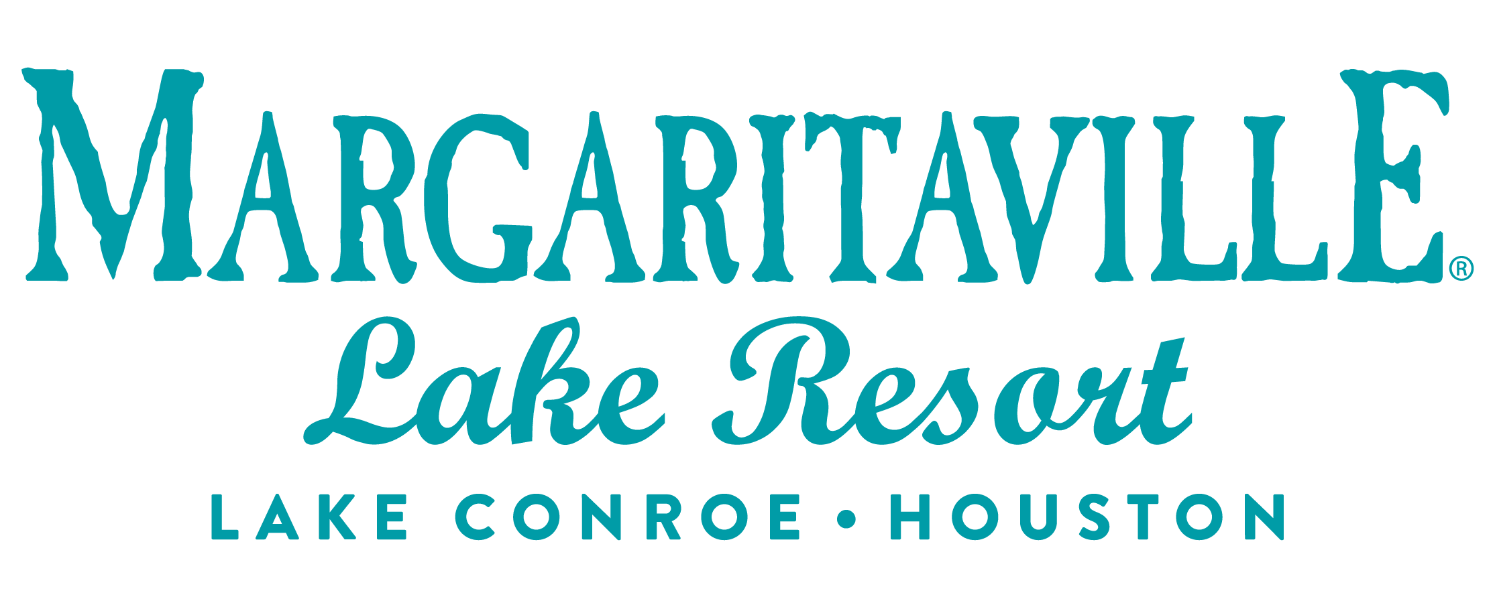
Storyteller Communications
713-594-2141 phone
christy@storytellercomm.com

DRAFT
MEDIA ALERT
Celebrate your love lakeside this Valentine’s Day at Margaritaville Lake Resort, Lake Conroe | Houston

WHAT: Express your love for that someone special by reserving the Margaritaville Lake Resort, Lake Conroe | Houston’s “Love in the Library” Suite for a night or two. The Jimmy Buffett, penthouse, presidential suite has been transformed into a lover’s paradise with romance novels, a “Love Potion” cocktail bar, rose petals, floral arrangements from Bride and Bloom, bubble bath, mood lighting, a bottle of “Love in the Library” wine, created by our friends at Bernhardt Winery and much more. A gallery of photos is available here.

Make them swoon by booking one of the resort’s romance packages, Romantic Affair, and Lounging in Love. The Romantic Affair package includes a dozen red roses, a bottle of Veuve Clicquot Champagne, and margarita-infused strawberries. When you book the Lounging in Love package, prosecco and margarita-infused strawberries will be awaiting your arrival as well as complimentary access to the amenities, including the relaxation lounge, steam rooms, and rain showers at St. Somewhere Spa.

You can also celebrate your love lakeside with a cozy candlelight dinner for two at Waterside Cove on Saturday, Feb. 11. Savor a three-course prix-fixe dinner, with romantic live music and wine-tasting, as you soak in stunning views of Lake Conroe. Reservations are strongly encouraged by calling 877.286.9590. All guests will be greeted with a rose from Belle and the Beast from the “Beauty and the Beast.”

Or dine at License to Chill Café and Bar, on both Saturday, Feb. 11, 2023, and Tuesday, Feb. 14, 2023, to enjoy featured Valentine’s Day specials and take a Valentine’s Romance cruise around Lake Conroe.

Rejuvenate at St. Somewhere Spa with a relaxation treatment sure to melt your worries away. The resort is offering a 50-minute couple’s massage with two glasses of champagne, two truffles, and a single red rose for $325 per couple over Valentine’s Day weekend. Call the spa to book a treatment time at 936-448-3100.

For more details, visit https://www.margaritavilleresorts.com/margaritaville-lake-resort-lake-conroe/destination-guide/lovers-in-paradise.

WHEN: The “Love in the Library” suite is available from Thursday, Feb. 9 through Wednesday, Feb. 19.
Saturday, Feb. 11 (Valentine’s Candlelight Dinner and License to Chill Bar & Café specials)
Tuesday, Feb. 14 (License to Chill Bar & Café specials/Valentine’s Day Cruise)

WHERE: Margaritaville Lake Resort, Lake Conroe | Houston
600 Margaritaville Parkway, Montgomery, TX 77356

WHAT ELSE: About Margaritaville Lake Resort, Lake Conroe | Houston
The Margaritaville Lake Resort, Lake Conroe | Houston, an all-suite resort, features 335 guest suites; including 32 lakefront cottages, on 186 lakefront acres on Lake Conroe. It is the first Margaritaville Resort in Texas. Bars and restaurants feature signature Margaritaville dining concepts – the LandShark Bar & Grill with boat slips on Lake Conroe, the 5 o’Clock Somewhere Bar, the Lone Palm Pool Bar, the License to Chill Bar & Café, Joe Merchant’s Coffee & Provisions, Boathouse Bar and Lounge, and a Margaritaville Retail Shop.

Margaritaville Lake Resort, Lake Conroe | Houston offers an array of recreational activities: an 18-hole golf course, a three-acre waterpark with a lazy river and outdoor pools, pickleball, tennis, swimming, boating, and fishing. Margaritaville’s popular full-service St. Somewhere Spa, and a spacious, Fins Up Fitness Center, provide exceptional wellness options. With 72,000 square feet of indoor/outdoor IACC-approved meeting space, the resort can host special events and meetings of every size. Located just an hour from Houston and about three hours from the major hubs of Austin, Dallas and San Antonio, the resort is within easy reach of over 19 million Texans. The project is a joint venture of Songy Highroads (SHR) and The Wampold Companies. The Margaritaville Lake Resort, Lake Conroe |Houston, is part of BENCHMARK®, a global hospitality company’s Benchmark Resorts & Hotels portfolio.

About Benchmark Pyramid
Benchmark Pyramid was formed by the 2021 merger of two hotel and resort management companies, creating the most owner-focused, experiential company in the industry and its best workplace. The organization’s global portfolio spans more than 240 properties in the U.S., Caribbean and Europe. It maintains offices in Boston; The Woodlands, Texas; Cincinnati; and London. For more information, visit https://link.edgepilot.com/s/572d5ef4/mpYNmZgk70OA6lmvMoV-Jw?u=http://www.benchmarkpyramid.com/.

# # #

